CONTACT INFORMATION
Name:
If this application is being submitted by a partnership check here: ☐
Mailing Address:
Applicant Contact Name: | Title:
Are you the primary contact for this grant: ☐YES ☐ NO
Email:
Telephone:
Do you currently have an open MCFMLD grant? ☐ YES ☐ NO
If yes, provide your grant number(s):

PROJECT INFORMATION
Project Title:
Application Type (check only one):
- Traditional Grant Application
- Mini Grant Application
Project described herein will start no later than (mm/dd/yyyy):
Impacted Community(ies):
City (location of project, including cross streets):
Traditional Grant Request:
Total Project Cost:
Percent of overall match (% of total project cost) (example 30% type .30):
Percent of cash match (% of total project cost) (example 10% type .10):

Mini Grant Request (not to exceed $50,000):
Total Project Cost:
Note: Mini Grant Applications have no matching requirements.
Brief Project Description (In a separate document, answer the three questions below in a total word count of 250 words (250 total, not 750) or less:)
- What is the proposed project, including all components?
- Explain how your project is consistent with the Mission Statement of the MCFMLD.
- How will your project benefit communities impacted by the development of natural resources locally?
- Please specify word count on project description document.

APPLICATION CHECKLIST
Submit this application with the following required documents in the following order:
- Brief Project Description
- Response to Application Questions (narrative, on your own paper)
- Budget (applicants must use the MCFMLD Budget Form, budgets submitted in any other format will be rejected)
- Preliminary Timeline Estimate
- Intergovernmental Agreement or Memorandum of Understanding, if applicable
- Signed Resolution from Governing Body
- Attachments, if applicable:
- Map(s) identifying the project location
- Site map
- Up to five letters of support
- Photos of existing public works or capital projects to be replaced, if applicable
- Documentation of any opposition to the project, if applicable

By signing below, the applicant certifies that it owns, leases, or otherwise has control over the property on which this project will be completed (collectively, “Control”) (or is applying on behalf of an entity that has such Control). Applicant has on file documentation evidencing its Control of the property and will provide such documentation to MCFMLD on request. The Applicant hereby certifies and warrants that any and all statements and representations including all sources and uses of funds made in this Grant Application are true and correct and may be relied upon by the MCFMLD.

Authorized Signature: _______________________________________ Date: _____________
(From applicant organization) (mm/dd/yyyy)

Printed Name and Title: _________________________________________________________

Traditional Grant Program. All applicants for the Traditional Grant Program must respond to the following selection criteria questions in no more than nine (9) pages. This application will be scored on an 80-point basis with questions 1-10 below worth from one to ten points each. The nine-page limit does not include the proposed budget, attachments, photographs, maps, letters, etc., but the total page count for your entire submittal may not exceed 25 pages.

In a separate document, please answer every question, restating the question that you are answering in full. Failure to provide a response to any question will reduce your project’s score. Please reference all attachments. Twelve-point font or greater and standard margins required. No double-sided printing.

Qualifying Questions
Please note that the qualifying questions are not scored but are instead used to evaluate whether the application meets eligibility requirements.

- Under federal law, MCFMLD distributions may only be made to the State, or its political subdivisions. Political subdivisions of the State include municipalities, school districts, public and state-controlled institutions of higher education, library districts, metropolitan or other special districts, and fire protection districts. Explain how your organization qualifies as the State or a political subdivision of the State.
- Under federal law, your proposal must be one of the following three types: (1) planning, (2) construction and maintenance of public facilities, or (3) provision of public services. Describe the scope of the project – what exactly will be built. Be specific, explaining preparatory work, quantities, dimensions, etc. If the project is intended to enhance, rehabilitate, or replace existing public works or other capital projects, describe the state of the existing public works or other capital projects.
- Eligible projects must be completed within two years of the award date. Using the sample Timeline provided by MCFMLD as a guide, please illustrate the timeline for completion of your project. Describe the planning, design, and engineering that have gone into the project thus far. Identify a “no later than” start date for the project.
- This traditional grant application requires that a minimum of 30% of all the resources required to complete the proposed project must come from sources other than MCFMLD and that a minimum of 10% of the total project costs must be in the form of a cash match from the applicant and/or partners. Please explain what matching funds that will be provided for this project and how the minimum matching requirement will be met.
Selection Criteria Questions
Applications are scored based on responses to the following seven questions.

Impact / Mission Questions

- Does energy extraction create physical impacts that affect your organization? Explain these effects and their impact on your organization. How does this project mitigate these impacts? Please provide as much supporting data as possible.

- How do the social impacts of energy extraction affect your organization? Specify if your organization is directly or indirectly impacted. How does this project address these impacts? Please provide as much supporting data as possible.

- Please describe how this project will help the MCFMLD fulfill its mission to “enhance positive social and economic impact in Mesa County from the development, processing and energy conversion of fuels and minerals leased under the Federal “Mineral Lands Leasing Act” through strategic grants, partnerships and leadership.” Explain how this project will enhance our community. If there has been opposition to this project, explain the nature of the concerns and how you will address them.

- Natural resources are finite in nature. Therefore, it is important to the MCFMLD that the funds derived from their development are invested in ways that reflect a long-term perspective on impacts. Please describe the anticipated useful life of this project and explain how this project delivers long-term value to the community.

Funding / Resource Questions

- How is this project being funded? Please provide a summary of all committed funding resources for this project, including sources, amounts, and dates which those funds will be available. Please provide a summary of uncommitted funding resources, including other grants, their status, and dates of funding decisions. What are your plans for raising any additional funds?

- How do you plan to fund future management and/or operating costs of this project? If this is a multi-phase project, where will future funding be acquired?

Funding Availability

- Excluding the funds sought in this grant application, have all funds needed for the completion of the project been secured from other funding sources or funds held by the applicant? If the answer is no, please provide all details at to the source(s) of the funding requests, the amount of all other funding requests needed for the completion of the project, and the date(s) when the applicant will know if those funding requests are approved.

Sustainability Questions

- How long has your organization or partnership existed? Please describe your accomplishment of similar projects, and list which partners were involved with those projects.

Additional Information
This “Additional Information” section is not scored but is asked to help the reviewers understand more about the nature of the project.

- Would your project proceed with partial funding of this application? How does the scope of the project change with different levels of funding?

Mini Grant Program. All applicants for the Mini Grant Program must respond to the following selection criteria questions in no more than five pages. This application will be scored on a 60-point basis with questions 1-5 below worth from one to ten points each. The five-page limit does not include the proposed budget, attachments, photographs, maps, letters, etc., but the total page count for your entire submittal may not exceed 15 pages.

In a separate document, please answer every question, restating the question that you are answering in full. Failure to provide a response to any question will reduce your project’s score. Please reference all attachments. Twelve-point font or greater and standard margins required.

Qualifying Questions
Please note that the qualifying questions are not scored but are instead used to evaluate whether the application meets eligibility requirements.

- Under federal law, MCFMLD distributions may only be made to the State, or its political subdivisions. Political subdivisions of the State include municipalities, school districts, public and state-controlled institutions of higher education, library districts, metropolitan or other special districts, and fire protection districts. Explain how your organization qualifies as the State or a political subdivision of the State.
- Under federal law, your proposal must be one of the following three types: (1) planning, (2) construction and maintenance of public facilities, or (3) provision of public services. Describe the scope of the project – what exactly will be built. Be specific, explaining preparatory work, quantities, dimensions, etc. If the project is intended to enhance, rehabilitate, or replace existing public works or other capital projects, describe the state of the existing public works or other capital projects.
- Eligible projects must be completed within one year of the award date. The purpose of the mini-grant program is to complete smaller projects immediately (complete within one year) and otherwise to meet immediate needs, all consistent with federal and state statutory purposes. Demonstrate your ability to do this.
- If this application is for a Planning Grant, the MCFMLD will fund no more than 50% of that project; a 50% cash only match is required; and the 50% cash match must be the first money expended on the project. Please explain how this matching requirement will be met.

Selection Criteria Questions
Applications are scored based on responses to the following five questions.

Impact / Mission Questions

- Does energy extraction create physical impacts that affect your organization? Explain these effects and their impact on your organization. How does this project mitigate these impacts? Please provide as much supporting data as possible.

- How do the social impacts of energy extraction affect your organization? Specify if your organization is directly or indirectly impacted. How does this project address these impacts? Please provide as much supporting data as possible.

- Please describe how this project will help the MCFMLD fulfill its mission to “enhance positive social and economic impact in Mesa County from the development, processing and energy conversion of fuels and minerals leased under the Federal “Mineral Lands Leasing Act” through strategic grants, partnerships and leadership.” Explain how this project will enhance our community. If there has been opposition to this project, explain the nature of the concerns and how you will address them.

- Natural resources are finite in nature. Therefore, it is important to the MCFMLD that the funds derived from their development are invested in ways which reflect a long-term perspective on impacts. Please describe the anticipated useful life of this project and explain how this project delivers long-term value to the community.

Sustainability Questions

- How long has your organization or partnership existed? Please describe your accomplishment of similar projects, and list which partners were involved with those projects.

Funding Availability
- Excluding the funds sought in this grant application, have all funds needed for the completion of the project been secured from other funding sources or funds held by the applicant? If the answer is no, please provide all details at to the source(s) of the funding requests, the amount of all other funding requests needed for the completion of the project, and the date(s) when the applicant will know if those funding requests are approved.

Additional Information
This “Additional Information” section is not scored but is asked to help the reviewers understand more about the nature of the project.

- Would your project proceed with partial funding of this application? How does the scope of the project change with different levels of funding?

Resolution Supporting the Grant Application for a Grant from the Mesa County Federal Mineral Lease District and the completion of (Name of Project).

- WHEREAS, the (Name of Eligible Applicant) is a political subdivision of the State of Colorado, and therefore an eligible applicant for a grant awarded by the Mesa County Federal Mineral Lease District (“MCFMLD”); and
- WHEREAS, the (Name of Eligible Applicant) has submitted a Grant Application for the (Name of Project) requesting a total award of (Amount Requested from MCFMLD); and
- WHEREAS, the (Name of Eligible Applicant) supports the completion of the project if a grant is awarded by the MCFMLD.

NOW, THEREFORE, BE IT RESOLVED BY THE (Governing Body of Eligible Applicant)
THAT:

- The above recitals are hereby incorporated as findings by the (Governing Body of Eligible Applicant).
- The (Governing Body of Eligible Applicant) strongly supports the Grant Application submitted by the (Name of Eligible Applicant) and has appropriated matching funds for a grant with Mesa County Federal Mineral Lease District.
- If the grant is awarded, the (Governing Body of Contracting Entity) strongly supports the completion of the project.
- The (Governing Body of Eligible Applicant) of the (Name of Eligible Applicant) authorizes the expenditure of funds necessary to meet the terms and obligations of any grant awarded pursuant to a Grant Agreement with the MCFMLD.
- The project site is owned by (Name of Eligible Applicant) and will be owned by (Name of Eligible Applicant) for the next 25 years. The (The Governing Body of Eligible Applicant) of the (Name of Eligible Applicant) will continue to maintain (Project Title) in a high-quality condition and will appropriate funds for maintenance annually.
- If a grant is awarded, the (Governing Body of Eligible Applicant) hereby authorizes the (Designated Official) to sign a Grant Agreement with the MCFMLD

The effective date of this Resolution is the date passed and approved below.

PASSED AND APPROVED ON: _______________________________

APPROVED BY:
Name

Title
PRELIMINARY TIMELINE ESTIMATE

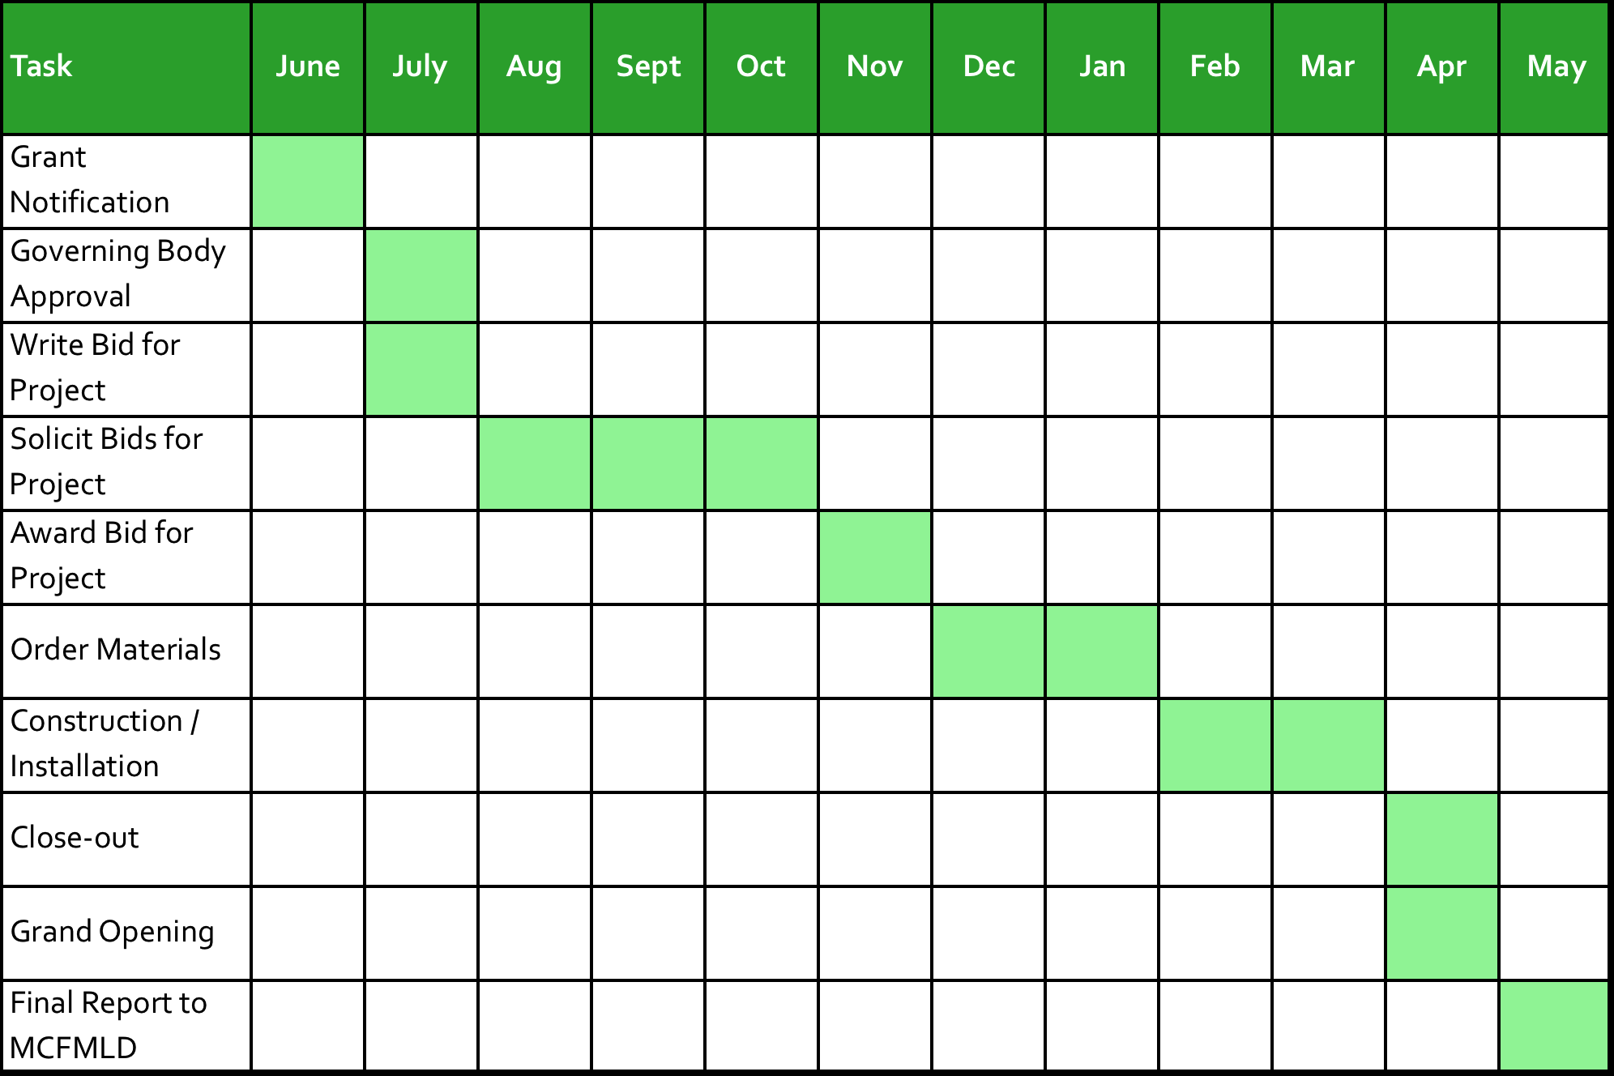
Sample of a Mini Grant Year 1 timeline estimate:

NOTE: Applicants have up to two years from the date of award to complete projects under the Traditional Grant Program and up to one year in the Mini Grant Program. Applicants in both programs MUST identify a “no later than” start date for every project, your good faith estimate of the date by which the project will commence. This date varies depending on the type of project. The MCFMLD may take this date into consideration in making its decisions.

Indicate this date and briefly describe the action(s) you consider “starting” the project. Examples: bid award date, groundbreaking, execution of construction contract, date of first program, etc.

You can find the above sample timeline in Excel format on our website: http://www.mesafml.org/current-grant-cycle/grant-applications/.
Applicants must use the MCFMLD Budget Form available in Microsoft Excel format at http://www.mesafml.org/current-grant-cycle/grant-applications/. Budgets submitted in any other format will be rejected.

